PRD: AI-Enhanced LMH Journal App
Sep 28, 2026 · @abhay

Overview and problem
This PRD covers enhancing the existing LMH journal app, which today offers bereaved writers fixed prompts with no AI, by adding AI prompts that help writers go deeper into their thoughts and feelings within a defined depth limit that keeps the writing from becoming traumatizing.
Background. After the first weeks of a loss, support from others often fades while the grief does not. Many bereaved people stop talking about the person who died, even though they still think about them constantly. Pennebaker's research suggests holding back like this is costly, and that writing about difficult experiences can help.
Why fixed prompts fall short. Expressive writing helps most when people engage deeply with both what happened and how it felt, and its weak results in bereavement may come from people writing at the surface (Stroebe et al., 2002). Fixed prompts cannot respond to what a writer has actually written. Adaptive AI prompts can, but they carry a real risk: pushing a grieving person too deep, too fast.
What we're building. Three additions to the LMH app: adaptive AI deepening prompts during writing, a layered depth limit that caps how far and how fast those prompts go, and next-day continuity with a short AI summary and a choice of where to go next.
One-line summary. AI prompts that help bereaved people write more deeply, with a depth limit that keeps distress within a safe range.

Goals, non-goals and principles
The enhancement succeeds if writers go deeper with AI prompts than they do with fixed prompts alone, while distress stays within safe limits and they keep coming back.
Goals
- Help writers go deeper into their thoughts and feelings about their loss with adaptive AI prompts.
- Enforce a depth limit (prompt budget, depth ladder, adaptive de-escalation) so prompts never push writers into trauma.
- Deliver a clear three-stage experience: instructions, writing session and next-day return.
- Give writers continuity across days with a short AI summary and a choice of where to go next.
- Detect elevated risk and route writers to help quickly.
- Earn trust through privacy strong enough that writers write honestly.
Non-goals
- Grief therapy or treatment of prolonged grief disorder.
- Any AI that recreates, simulates or speaks as the person who died.
- AI companionship or conversation outside the writing sessions.
- Streaks, gamification or engagement for its own sake.
- A formal research study for now; the app should be built so one can be run later.
Guiding principles
- The writer leads. The AI suggests; it never writes, rewrites or completes the writer's text.
- Deeper, but never too deep. Every prompt passes through the depth limit, and the limit always wins over the goal of going deeper.
- Facts and feelings together. Prompts invite both what happened and how it felt.
- Bonds can continue. Writers can write about or to the person who died; the goal is not "letting go" or "closure."
- No grief timelines. Nothing implies stages, deadlines or a right way to grieve.
- Short-term pain is expected. Writers are told that feeling worse right after writing is common.
- Writers control depth. They can dismiss prompts, turn them off, or end a session at any time.

Target users
The app is for bereaved adults who lost a close person at least a few weeks ago and want a private, guided way to write about the loss.
Who it's for
- Adults 18 or older who have lost a family member, partner or close friend.
- People at least a few weeks past the death, including those grieving for months or years.
- Writers comfortable using a phone or computer for 20-minute sessions.
Who it's not for (onboarding redirects them)
- People in the first few weeks after a death, who are offered lighter support and resources instead.
- People in acute crisis, who are shown crisis resources right away.
- People bereaved by suicide or homicide, until an adapted, clinically reviewed version exists.
- Anyone under 18.
User segments
Segment | What they need | Design implication
Recently bereaved (under 6 months) | Gentle pacing; a place to keep talking about the person | Lower ladder ceilings in early sessions; strong grounding close
Long-term grievers (6 months or more) | Structure, and a nudge toward help if grief stays intense | Optional periodic grief self-check with referral information
Partners and parents who lost a child | Extra care; higher risk | Lower threshold for safety check-ins
Caregivers after a long illness | Room for exhaustion, relief and guilt together | Prompts that allow mixed feelings without judgment

Theoretical and empirical foundation
Every part of the enhancement traces back to a Pennebaker finding or an established grief theory; this table links each finding to a product requirement.
Finding | Evidence | Product requirement
Expressive writing did not reduce grief overall in a large bereavement trial | Stroebe et al., 2002 | Adaptive prompts that move writing beyond the surface
Facts plus feelings drives benefit; either alone does not | Pennebaker and Beall, 1986 | AI prompts invite whichever half is missing
Building a coherent story over sessions predicts benefit | Narrative and LIWC studies | Prompts invite sense-making but never write the narrative
Making sense of a loss predicts better adjustment | Meaning reconstruction (Neimeyer) | Higher ladder levels invite meaning without imposing it
Healthy grieving moves between facing the loss and rebuilding life | Dual Process Model (Stroebe and Schut, 1999) | Every session ends with a restorative landing prompt
Ongoing bonds with the deceased can be healthy | Continuing bonds (Klass, Silverman and Nickman, 1996) | Writing to or about the person is welcome; no "closure" framing
Continuous, uninterrupted writing for 15 to 20 minutes | Standard protocol | 20-minute sessions; prompts capped, spaced and kept out of the first and last minutes
3 to 4 sessions on consecutive or nearby days | Standard protocol | Daily sessions with next-day continuity, up to 4 per arc
Short-term distress, long-term benefit | Replicated across studies | Instructions normalize feeling worse; mood checked every session
Moderate negative emotion is best; extremes predict worse outcomes | LIWC analyses | Depth limit and adaptive de-escalation
Repeating the same story unchanged looks like rumination | Pennebaker's later work | Next-day choice offers a new angle or closing the topic
Less suitable in the immediate aftermath | Pennebaker's guidance | Onboarding redirects people in the first few weeks after a death
Prolonged grief disorder is a distinct, measurable condition | PG-13-R (Prigerson et al., 2021) | Optional self-check with referral information when scores are high
Expressive writing's value in bereavement is still unproven, and AI deepening adds both promise and risk, which is why the depth limit is the core of this PRD.

App experience: three stages
The enhanced app keeps the LMH journal's structure and adds AI in two places, deepening prompts during writing and continuity the next day, organized into three stages.
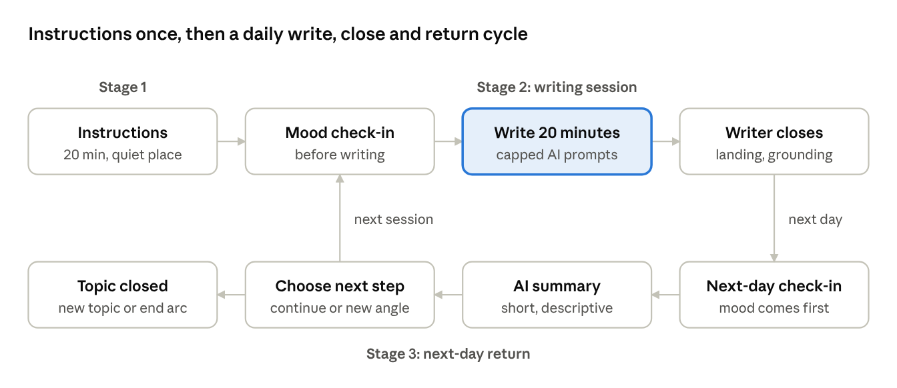
three-stage flow · instructions, writing session, next-day return

What changes from the current app
Area | Current LMH app | Enhanced LMH app
Instructions | Not structured around Pennebaker's protocol | Stage 1 instructions at first login, short reminder each session
Prompts while writing | Fixed prompts | Opening prompt, then adaptive AI prompts at pauses and on request, under the depth limit
Session structure | Open-ended | 20 minutes: settle, deepen, land, then close
Safety while writing | None specific to prompts | Depth limit, de-escalation, "this is a lot right now" button
Next day | Start fresh | Mood check-in, AI summary, suggested prompts and a choice of next step

Stage 1: instructions
Shown in full at first login and as a short reminder before each session. Based on Pennebaker's protocol, the writer is told to:
- Write for 20 minutes without stopping.
- Find a quiet, private place where they won't be interrupted, and silence their phone.
- Write about their deepest thoughts and feelings about their loss and the person who died, including both what happened and how it felt.
- Not worry about spelling, grammar or structure.
- Feel free to write to the person, not only about them.
- Expect that they may feel sad afterward, which is normal and usually passes.
- Stop or switch topics if something feels like too much.
The screen also explains that AI prompts are optional suggestions they can dismiss or turn off, who can read their writing, and where to find crisis resources. The writer confirms they have read it before the first session.

Stage 2: writing session
Minutes | Phase | What happens
Before | Check-in | Mood rating (0 to 10)
0 to 5 | Settle | Opening prompt (fixed LMH prompt, or the next step chosen in Stage 3); no AI prompts
5 to 15 | Deepen | AI prompts allowed within the depth limit
15 to 20 | Land | No deepening prompts; one restorative landing prompt offered
After | Close | Writer closes the session; mood rating and an optional one-minute grounding step
The writer can close at any point, and closing early is never framed as failure. If they keep writing past 20 minutes, no further AI prompts appear.

Stage 3: next-day return
- Mood check-in first. If the last session ended with a large rise in distress or today's mood is low, the writer is offered a lighter start before anything else.
- AI summary. A short, descriptive summary of what they wrote last time (rules in the AI specification below).
- Suggested prompts. Two or three AI-suggested prompts that pick up threads from the last session, plus one new-angle prompt.
- Choice of next step. Continue this topic, write about a new side of the same loss, mark the topic as done ("I've said what I needed to"), or try something lighter today.
An arc runs up to 4 sessions. When a topic is marked done or the arc ends, the writer can start a new topic or stop. Reminder notifications never include any content from the writing.

Supporting features
- Onboarding. Account setup, a short safety screen and loss details (time since death, relationship, expected or sudden death) used to set early ladder ceilings.
- Personalization. The name of the person who died, so prompts say "your mom" or "Sam."
- Settings. Turn pause-triggered prompts, on-request prompts and next-day summaries on or off.
- Optional grief self-check. The PG-13-R offered every few weeks, with referral information when scores are high.
- Reminders. Optional daily reminder with no content from the writing.

AI prompts and the depth limit
The AI's job is to help writers go deeper into their thoughts and feelings; the depth limit decides how deep and how often, and whenever the two conflict, the limit wins.

When prompts appear
- Pause-triggered. After about 60 seconds without typing during the deepen phase, a prompt appears as a dismissible card beside the text, never inside it.
- On request. A "Help me go deeper" button is available in the settle and deepen phases. The AI reads what the writer has written so far in the session and returns one prompt.

The depth limit
The limit has six layers, so no single rule carries all the weight. All values are starting points to be calibrated during beta.
Layer | Rule | Starting value
1. Prompt budget | Maximum AI prompts per session | 4 in total, no more than 2 of them pause-triggered
2. Spacing | Minimum gap between prompts | 4 minutes for pause-triggered, 2 minutes for requested
3. Timing | When prompts are allowed | No pause-triggered prompts in minutes 0 to 5; no deepening prompts after minute 15
4. Depth ladder | How intense a prompt can be | One level up per prompt, with a ceiling per session (below)
5. De-escalation | When deepening stops | Distress signals lower or stop prompts (below)
6. Writer control | What the writer can switch off | Dismiss any prompt; "no more prompts today"; two dismissals in a row stop pause-triggered prompts for the session

Depth ladder
Level | Purpose | Example | Allowed from
1. Open up | Say more | Can you say more about that? | Session 1
2. Feelings | Name what was felt | What did you feel in that moment, and what do you feel now? | Session 1
3. Meaning and relationship | Explore the bond and what it means | What do you miss most about her? | Session 2
4. Approach what was avoided | Gently return to something touched and dropped | You mentioned the hospital and moved on. Would you like to stay with that for a moment? | Session 3, only if today's mood is not low and nothing has triggered de-escalation
Never allowed at any level: asking for sensory reliving of the death ("describe exactly what you saw"), questions that assign blame or ask what the writer could have done differently, and comparisons with other people's grief. The writer may raise these themselves; the AI never introduces them.

De-escalation rules
Signal | Response
Writer taps "this is a lot right now" | No more deepening this session; one stabilizing prompt ("What has been helping you get through these days?") or silence; grounding offered
Low mood at the pre-session check-in | Ceiling drops to Level 2 for this session
Writer pauses the session | No pause-triggered prompts for the rest of the session
Crisis language flagged by the risk classifier | All prompts stop; Tier 3 safety response
Distress rose by 3 or more points after a session | Next session's ceiling drops one level
Two sessions in a row with a rise of 3 or more points | Ceiling stays at Level 2 and the app offers a check-in with support resources

Calibrating the limit
Grief clinicians review the starting values and a bank of example prompts at each level before beta. During beta, the team compares change in distress per session with the number and level of prompts received and adjusts the values. Values live in configuration, so they can be tuned after launch without a new release, and every change is reviewed by a clinician. The target is that no more than 15% of sessions show a distress rise of 3 or more points.

Prompt style
- One prompt at a time, under 25 words, framed as a question or gentle invitation.
- Invites whichever half is missing: feelings when the writing is all events, the story when it is all feelings.
- Uses the writer's own words and the name of the person who died where it fits.
- Never writes sentences for the writer, interprets the loss, gives advice, diagnoses, praises the writing or speaks as the person who died.

Next-day AI summary
- Two or three sentences in plain language describing what the writer wrote about last time: topics, people and moments.
- Uses the writer's own words where possible.
- Does not interpret, diagnose, judge progress or name feelings the writer did not express.
- Leaves out graphic details and any crisis content.
- Example: "Yesterday you wrote about the last week at the hospital and the night you sat with your dad. You described feeling numb, and you mentioned his laugh."
- The writer can collapse the summary or turn summaries off.
- No summary is generated after a session flagged at Tier 2 or 3; the safety protocol takes over instead.

Quality and guardrails
- Model versions and system prompts are versioned; any change is tested against the red-team set and reviewed by a clinician before release.
- Every prompt and summary is logged with the text it responded to, and a random sample is reviewed regularly against this specification.
- An output guardrail checks every prompt and summary for interpretation, advice, diagnosis, impersonation, blame, graphic content or ladder violations, and substitutes a safe default if it fails.
- A red-team set of grief entries, including crisis language and abuse disclosures, must pass before beta and before each change.
- The LLM provider has zero data retention and does not train on user writing.

Safety and distress protocol
Bereavement raises suicide risk and writing about a loss can be distressing, so the app detects risk and routes writers to human help and crisis resources, and never tries to counsel them itself.

Screening and monitoring
- Onboarding. A short safety screen (adapted from C-SSRS items with clinical review); people in acute crisis see crisis resources immediately.
- Session check-ins. Mood ratings before and after each session; high distress triggers the response tiers below.
- Entry safety check. A risk classifier flags entries with suicidal ideation, self-harm, harm to others or abuse disclosure.
- Grief self-check. High scores on the optional PG-13-R show referral information for grief-specialized care.

Grief-specific risk
- Reunion thoughts. Wishes to "be with" the person who died are common in grief and not always suicidal. The classifier distinguishes passive longing from active intent, and ambiguous cases get a warm check-in with resources.
- Prolonged grief. Intense grief that persists gets a gentle suggestion to see a grief specialist, while the writer keeps full access to the app.
- High-risk losses. Writers who lost a partner or child get a lower threshold for safety check-ins.
- Hard dates. Writers can note an anniversary or birthday; sessions near it get an extra check-in.

Response tiers
Tier | Trigger | In-app response | Human follow-up
1. Elevated distress | Low mood or a large rise after a session, no risk language | Grounding close, option to pause or skip, support resources | None
2. Concerning | Passive death wishes or worsening across sessions | Warm check-in message, support resources and a suggestion to talk to someone they trust or a professional | If LMH has a support team, a contact offer
3. Acute risk | Explicit suicidal intent, self-harm intent or intent to harm others | Writing pauses; crisis resources shown immediately (988 Suicide and Crisis Lifeline in the US) with one-tap call or text | Escalation path to be defined with LMH's clinical team

Depth guardrails
The depth limit (see AI prompts and the depth limit) governs everything the AI does. These guardrails cover the rest of the experience.
Moment | Guardrail
During writing | Pause, end session and "this is a lot right now" are always visible
Crisis language | Tier 3 response immediately, overriding everything else
Session end | Every session ends with a landing prompt and an optional grounding step, so no one closes the app at their most raw point
After a hard session | After a large distress rise, the grounding step is shown by default and the next session opens with a check-in and a lighter option
Next-day return | Mood check-in always comes before the summary; no summary after a flagged session
Across sessions | Writers can pause an arc or skip sessions at any time
Missed sessions | One no-guilt reminder; skipping is framed as a valid choice

Clinical oversight
- A clinical advisor (grief specialist or psychiatrist) signs off on the depth limit, the prompt bank, tier definitions and crisis messages before beta.
- The risk classifier is validated on clinician-rated grief entries before beta, with sensitivity for acute risk as the key metric.
- Safety incidents and a sample of Tier 2 and 3 cases are reviewed monthly.
- Crisis messages never make promises about what a hotline will or will not do.

Privacy, consent and data handling
Privacy is part of the mechanism: Pennebaker's benefits depend on people writing what they normally hold back, so writers must know exactly who and what can see their entries.

Writers are told plainly
- That entry text is sent to an AI service to generate prompts and next-day summaries, and the service does not retain or train on it.
- That entries are checked automatically for safety risk, and what happens when risk is detected.
- That writing about a loss can be upsetting in the short term, and what support is available.
- That prompts and summaries can be turned off at any time.
- That they can export or permanently delete all their entries at any time.

Data handling
- Entries, check-ins and prompt logs are stored encrypted on a secure server, with access limited to named staff and audit logs.
- No human reads entries, except for safety review of flagged entries or a user-initiated support request, as stated in the privacy policy.
- The LLM provider has zero data retention and does not train on user writing.
- No ads, no selling or sharing of data, and minimal collection (no contacts, location or ad identifiers).
- Data is structured so a future research study could use it, but only with separate, explicit consent from writers.

Success metrics
The north-star metric is the share of sessions where writers accept an AI prompt and keep writing, with no large rise in distress afterward.
Metric | Definition | Proposed target
Prompt engagement | Share of AI prompts that writers act on (keep writing after) rather than dismiss | 50% or more
Safe sessions | Share of sessions with a distress rise under 3 points | 85% or more
Session completion | Share of started sessions that reach the landing phase | 70% or more
Next-day return | Share of writers who come back for a second session within 3 days | 60% or more
Arc completion | Share of writers completing 3 or more sessions on a topic | 50% or more
De-escalation rate | Share of sessions where the "this is a lot" button or another de-escalation rule fires | Monitored; spikes trigger a review of the depth limit
Summary acceptance | Share of writers who keep summaries turned on after a week | 70% or more
Spec adherence | Reviewed prompts and summaries that meet the specification | 90% or more
Writer feedback | "The prompts helped me go deeper" and "I felt safe writing" (agree or strongly agree) | 75% or more
Safety | Risk classifier sensitivity for acute risk on the clinician-rated test set | 95% or more
Targets are starting points, to be reset after beta.

Requirements
These are the launch requirements for the enhanced app, written as user stories first and then as testable functional and non-functional requirements.

User stories
As a... | I want to... | So that...
New writer | See clear instructions before my first session | I know how to write and what to expect
Writer | Write for 20 minutes without constant interruptions | I can stay in the flow
Writer who feels stuck | Ask for a prompt when I want one | I can go deeper on my own terms
Writer | Dismiss prompts or turn them off | I stay in control of my writing
Writer having a hard moment | Tell the app "this is a lot right now" | It stops pushing and helps me settle
Returning writer | See a short summary of what I wrote last time | I can pick up where I left off
Returning writer | Choose to continue, switch or close a topic | The journal follows where I am
Writer in crisis | Get help immediately | I am safe

Functional requirements
- FR-1 Instructions. Show Stage 1 instructions at first login with an acknowledgment, and a short reminder before each session.
- FR-2 Check-ins. Collect a 0 to 10 mood rating before and after each session.
- FR-3 Session timer. Run a 20-minute session with settle, deepen and land phases; the writer can close at any time.
- FR-4 Pause trigger. After 60 seconds without typing in the deepen phase, request a prompt from the depth limit engine.
- FR-5 On-request prompts. Show a "Help me go deeper" button in the settle and deepen phases.
- FR-6 Depth limit engine. Check all six layers before any prompt is shown, and log every allow or block decision with its reason.
- FR-7 Prompt display. Show prompts as dismissible cards beside the text, never inserted into it.
- FR-8 De-escalation button. Keep "this is a lot right now" visible throughout the session; tapping it applies the de-escalation rules.
- FR-9 Landing and grounding. Offer one landing prompt after minute 15 and an optional grounding step at close.
- FR-10 Next-day summary. Generate the summary at session close; show it after the next check-in; allow collapsing and turning summaries off.
- FR-11 Next step. On return, show suggested prompts and the four next-step choices.
- FR-12 Safety screening. Screen every entry with the risk classifier and apply the response tiers.
- FR-13 Settings. Let writers turn pause-triggered prompts, on-request prompts, summaries and reminders on or off.
- FR-14 Data control. Let writers export or permanently delete all their entries.

Non-functional requirements
- Latency. A prompt appears within 3 seconds of a trigger; if the writer starts typing again before it arrives, it is dropped.
- Fallback. If the AI service is unavailable, the app falls back to the current fixed prompts without interrupting the session.
- Auditability. Every prompt, summary and depth limit decision is logged and traceable to the configuration in force at the time.
- Security and privacy. Encryption in transit and at rest, access control and audit logs, as described in the privacy section.
- Accessibility. WCAG 2.1 AA, adjustable text size and screen reader support.
- Platforms. The same platforms as the current LMH app.

Technical architecture
The enhancement sits on top of the existing LMH journal: entries go to a secure server, and entry text reaches the AI service only when a prompt or summary is needed.
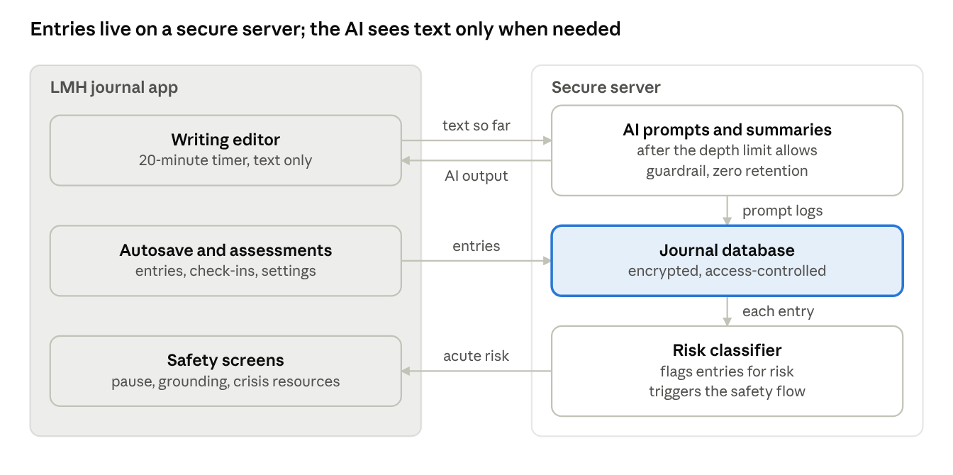
system architecture · app and secure server
The app sends the session's text so far when a prompt is triggered or requested, and the depth limit engine decides whether a prompt may be shown and at what level. At session close, the service generates the next-day summary. Every entry is saved to the journal database and screened by the risk classifier, which triggers the safety flow.
Component | Responsibility | Notes
LMH journal app | Instructions, writing sessions, check-ins, next-day return, settings, safety screens | Existing LMH journal extended with the three-stage flow
Depth limit engine | Enforces budget, spacing, timing, ladder ceilings and de-escalation rules | Rule-based and deterministic, so every decision is auditable; values set in configuration
AI prompt and summary service | Generates deepening prompts at an allowed level and next-day summaries | Versioned models and system prompts; output guardrail; zero data retention
Journal database | Entries, check-ins, prompt and summary logs, depth limit decisions | Encrypted; access-controlled; audit-logged
Risk classifier | Flags entries for the safety flow | Validated on clinician-rated grief entries before beta
Admin dashboard | Depth limit configuration, metrics, safety review queue, spec adherence reviews | Access-controlled and audit-logged

Release plan and milestones
The enhancement ships in four phases, and no phase starts until the gate before it is met: clinical sign-off before any user, a safe beta before launch, and real-world metrics before expansion.
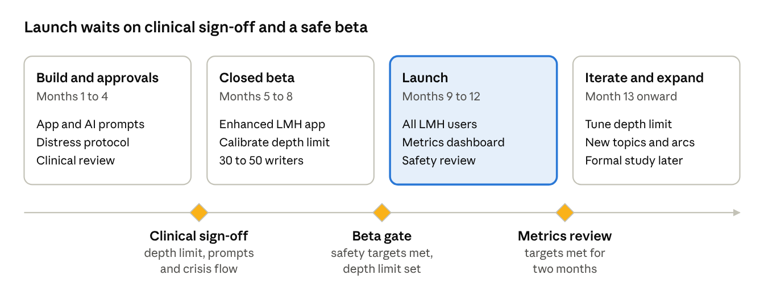
release roadmap · 4 phases, 3 gates
Month counts are planning placeholders. If beta misses its safety targets, the depth limit is tightened and beta repeats before launch.

Risks, open questions and assumptions
The biggest risk is that AI deepening pushes writers into distress rather than productive processing, so the depth limit and clinical oversight are built in from the start.

Risks
Risk | Impact | Mitigation
AI prompts push writers too deep, too fast | Distress, drop-off, possible harm | Six-layer depth limit, de-escalation rules, clinician-reviewed prompt bank
Depth limit set too tight, so prompts are too rare or too shallow to help | No real gain over fixed prompts | Beta calibration against writer feedback and distress
Pause-triggered prompts break the writing flow | Less immersive writing; annoyance | 60-second pause threshold, spacing rules, two-dismissals rule, settings to turn them off
Next-day AI summary misrepresents the writing or re-triggers pain | Distress; loss of trust | Descriptive-only rules, writer's own words, check-in first, option to collapse or turn off, guardrail review
AI summary does the sense-making for the writer | Weaker Pennebaker mechanism | Summaries describe, never interpret
Low return after the first session | Writers miss the multi-session benefit | Next-day summary and suggested prompts, gentle reminders, normalizing short-term distress
Missed acute risk in an entry | User harm | Validated classifier, crisis resources always visible, clinical oversight
Writers expect the AI to act like the person who died | Confusion or distress | Clear instructions; hard rule against impersonation
No human escalation path for acute risk | Unsafe gap in the safety flow | Define the escalation path with LMH's clinical team before beta
Data breach | Loss of trust; legal exposure | Encryption, access control, zero-retention LLM, audit logs

Open questions
- ☐ Who uses the current LMH journal app today, and in what setting (hospice, clinic, direct)?
- ☐ Which fixed prompts does the current app use, and should they stay as opening prompts?
- ☐ Does LMH have a clinical or support team that can respond to Tier 2 and 3 cases?
- ☐ Which distress measure works best at check-ins (0 to 10 mood, distress thermometer or SUDS)?
- ☐ Is a 3-point rise the right threshold for de-escalation, or should clinicians set it?
- ☐ Which LLM provider meets zero-retention and compliance needs?
- ☐ When and how to support people bereaved by suicide or violence?
- ☐ When to run a formal study, and what data the app should capture now to make that possible?

Assumptions
- Bereaved adults will accept AI prompts in a journal if they are optional, gentle and clearly limited.
- AI prompts can be kept to deepening only, without interpreting or writing for writers, reliably enough to ship.
- The current LMH app can be extended with the three-stage flow without rebuilding it.
- A grief-adapted, AI-enhanced journal may help where generic expressive writing showed weak bereavement results.

Key references
- Pennebaker and Beall (1986), original expressive writing experiment.
- Campbell and Pennebaker (2003), pronoun flexibility and health.
- Frattaroli (2006), meta-analysis of experimental disclosure.
- Stroebe, Stroebe, Schut, Zech and van den Bout (2002), expressive writing in bereavement.
- Stroebe and Schut (1999), the Dual Process Model of coping with bereavement.
- Klass, Silverman and Nickman (1996), Continuing Bonds.
- Neimeyer, meaning reconstruction in grief.
- Prigerson et al. (2021), PG-13-R measure of prolonged grief disorder.
- Pennebaker, Opening Up by Writing It Down and The Secret Life of Pronouns.

